BMP ID Form
Once logged into Unifier, select the DelDOT tab.
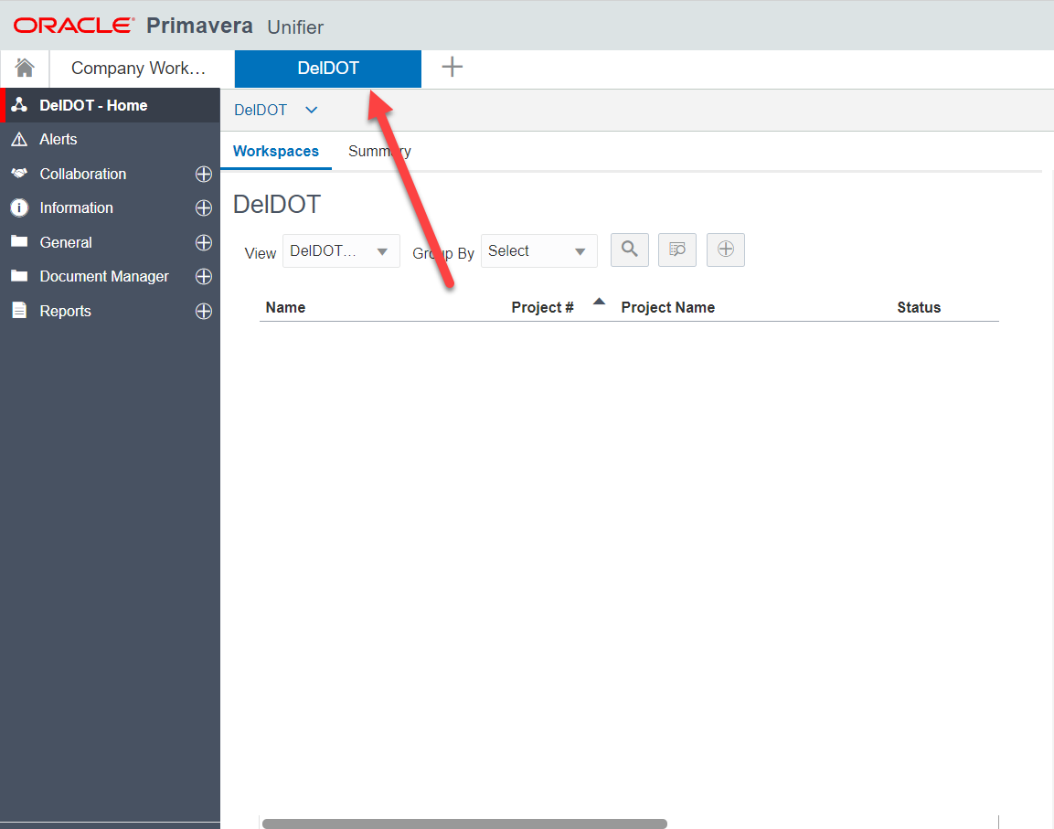
Make sure that the Blue Silhouette is in User Mode. Once in User Mode, click on the ( + ) next to General. This will open the drop-down menu. Click on the BMP ID form.
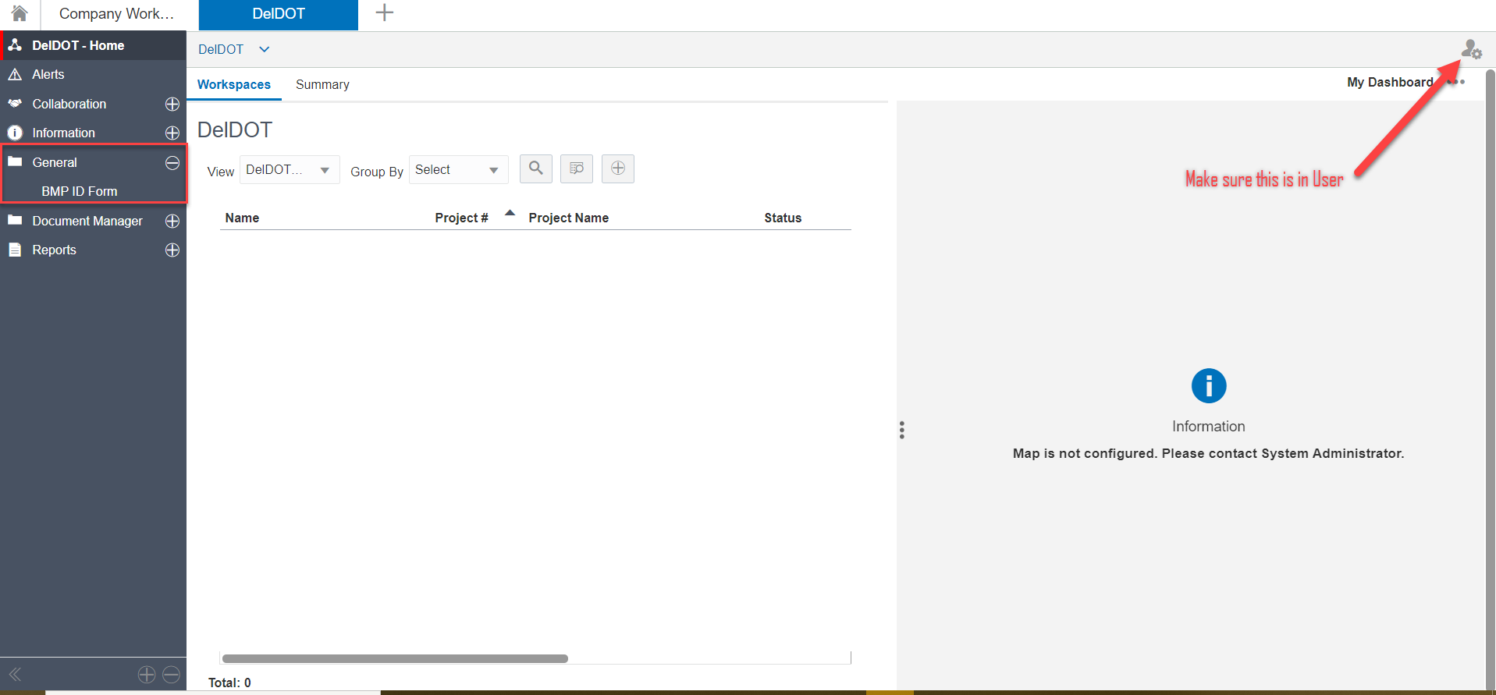
Once the BMP ID form is selected, click on the Create button to open a new form.
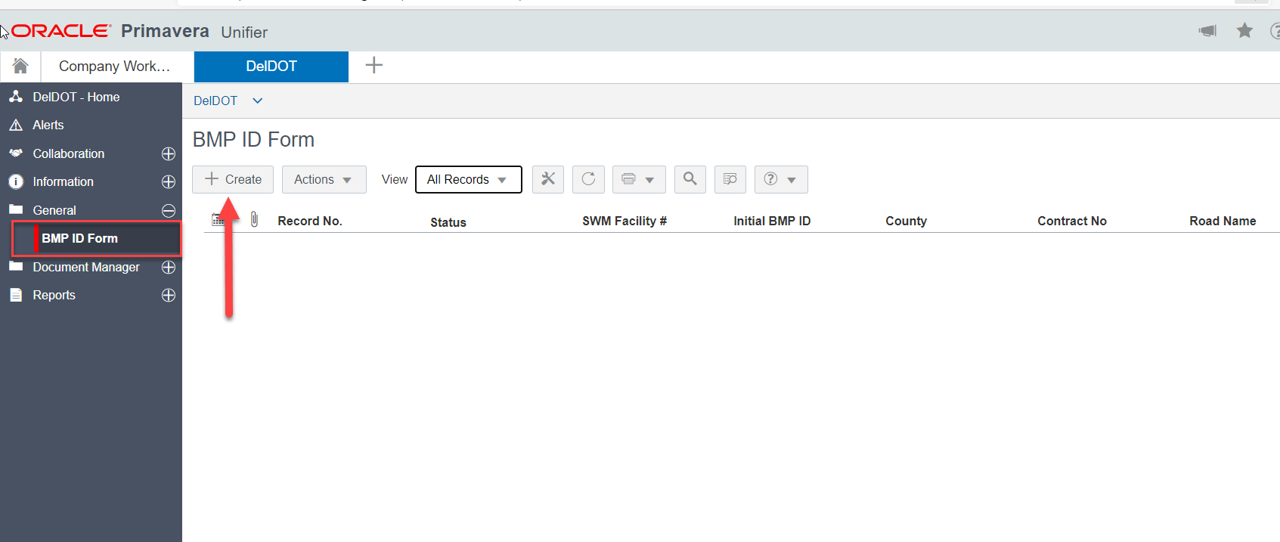

Once the form opens up, fill out the needed information under the General tab. To expand the Left side of the form, click on the three dot icon. This will expand the Left side and hide the right side (attachments, comments, and linked records).
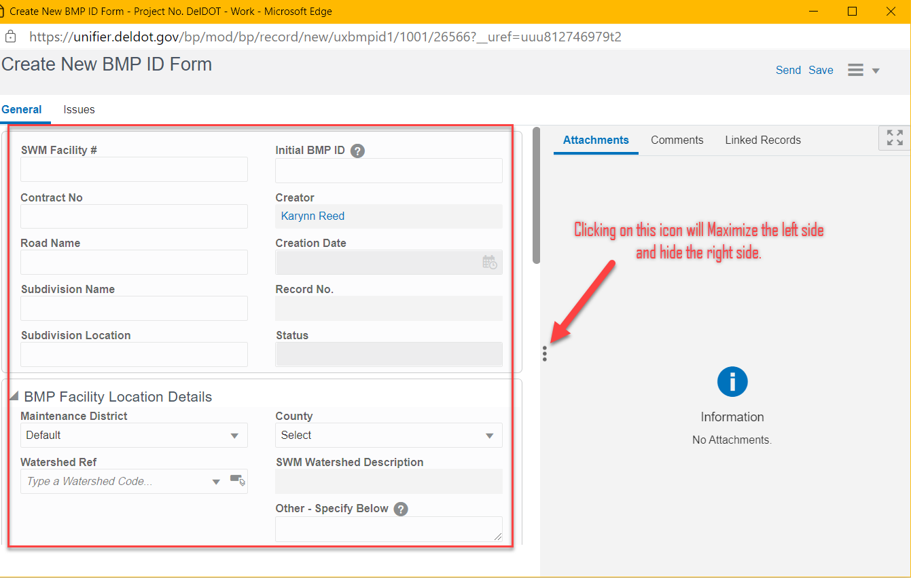
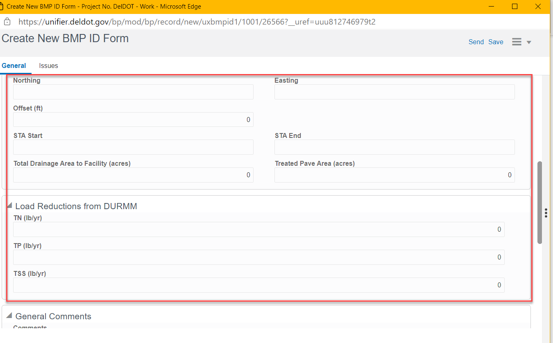
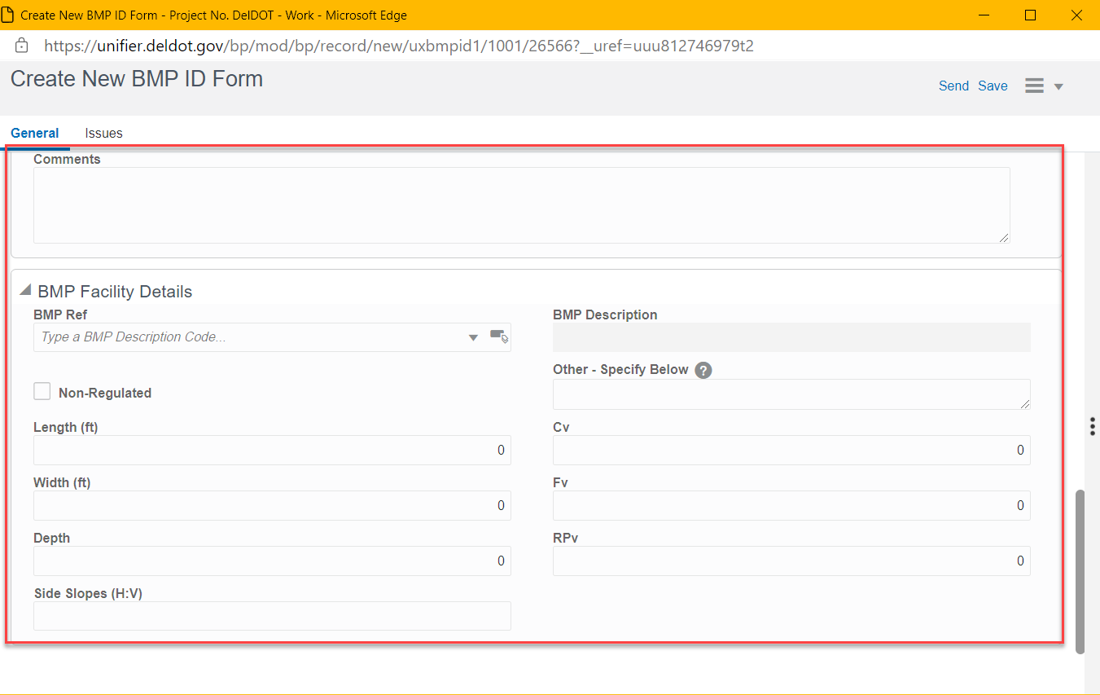
Once the General information of the form is filled out click on the Send button in the upper right hand corner.
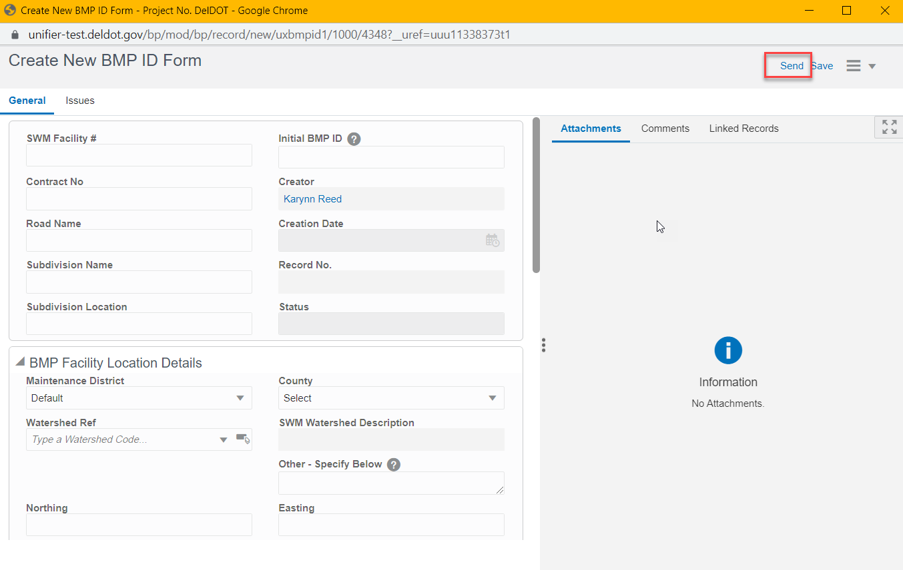
A Workflow Action Details screen will pop-up. Click on Send in the bottom right corner to Submit the form.
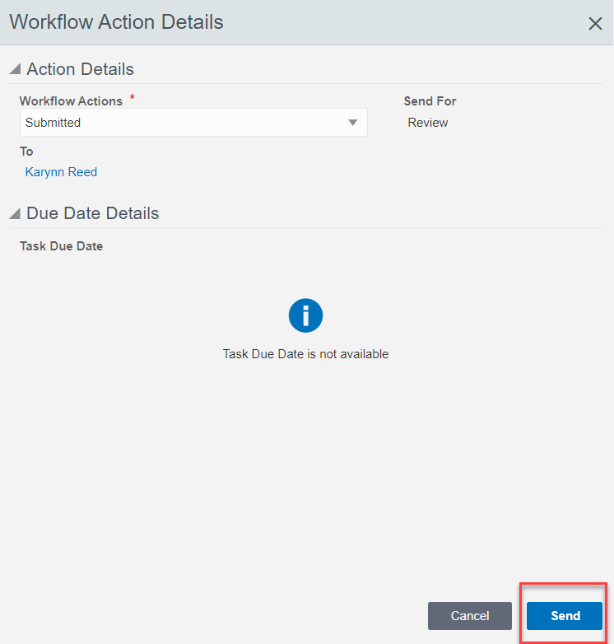
OPTIONAL: If Issues need to be added after the General information is completed, click on the Issues Tab. To add an issue, click on the Add button. If no Issues need to be noted, skip this step and click on the Send button in the upper right-hand corner.
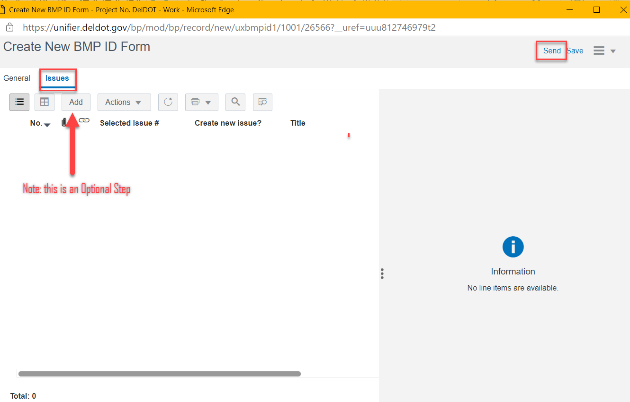
If an issue needs to be noted, click on the Add button. Fill out the information on the Right hand side of the form. Click Save and then the issue will appear on the Left side. If more than one Issue needs to be noted click on the Save and Add New button. Once the form is all filled out, click on the Send button in the upper right hand corner.
