BMP Description and SWM Watersheds List

Once logged into Unifier, make sure it is in User Mode by hovering over the blue silhouette in the upper right hand corner. If it is not switch to User Mode by clicking on the silhouette. Then click on the Company Workspace tab.
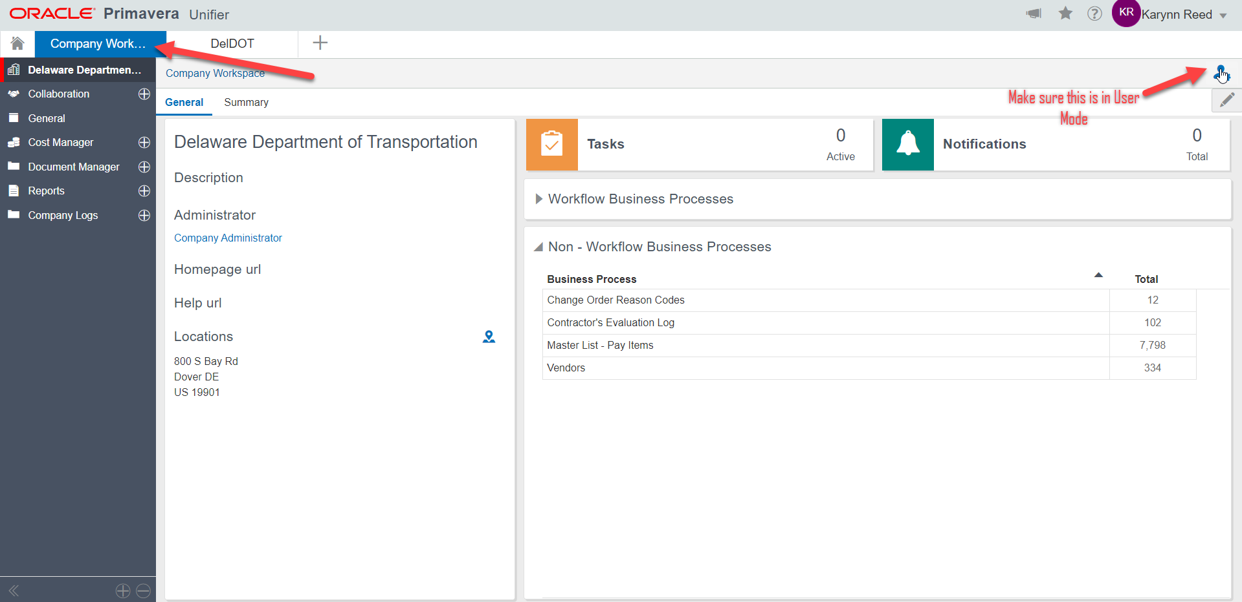
Click on the ( + ) next to Company Logs. This will open a drop down menu for the BMP Description and SWM Watersheds List.
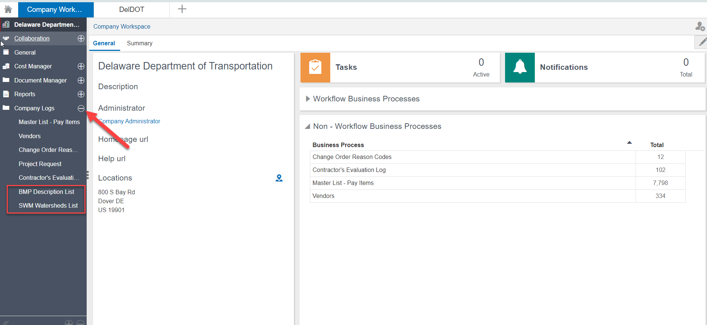
Once BMP Description or SWM Watersheds in selected, click Create.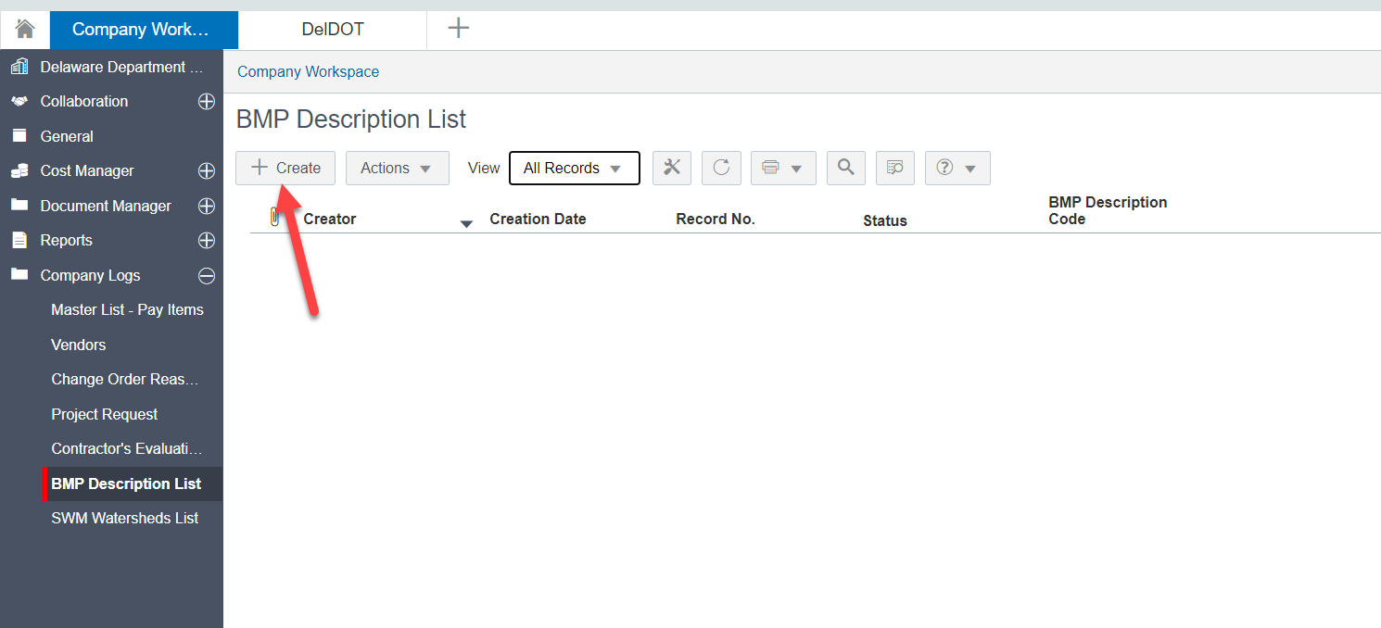
Once the window pops up, fill out the Required fields (BMP ID, BMP Description). Then click Submit to add the new BMP or Watershed.
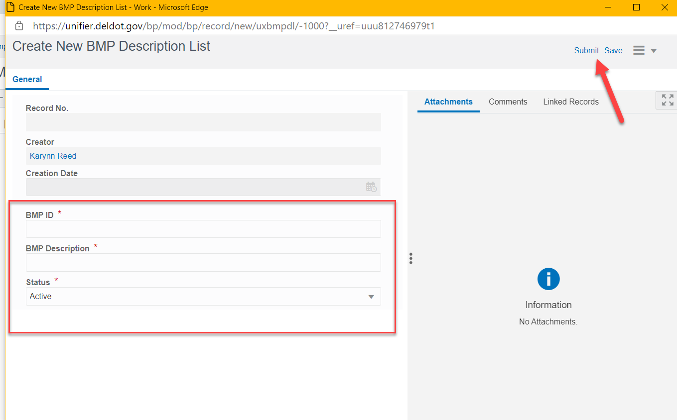
There are two methods to editing the record if a change needs to be made or the ID needs to be made inactive. One method is opening the record and clicking the Edit button on the top right hand corner.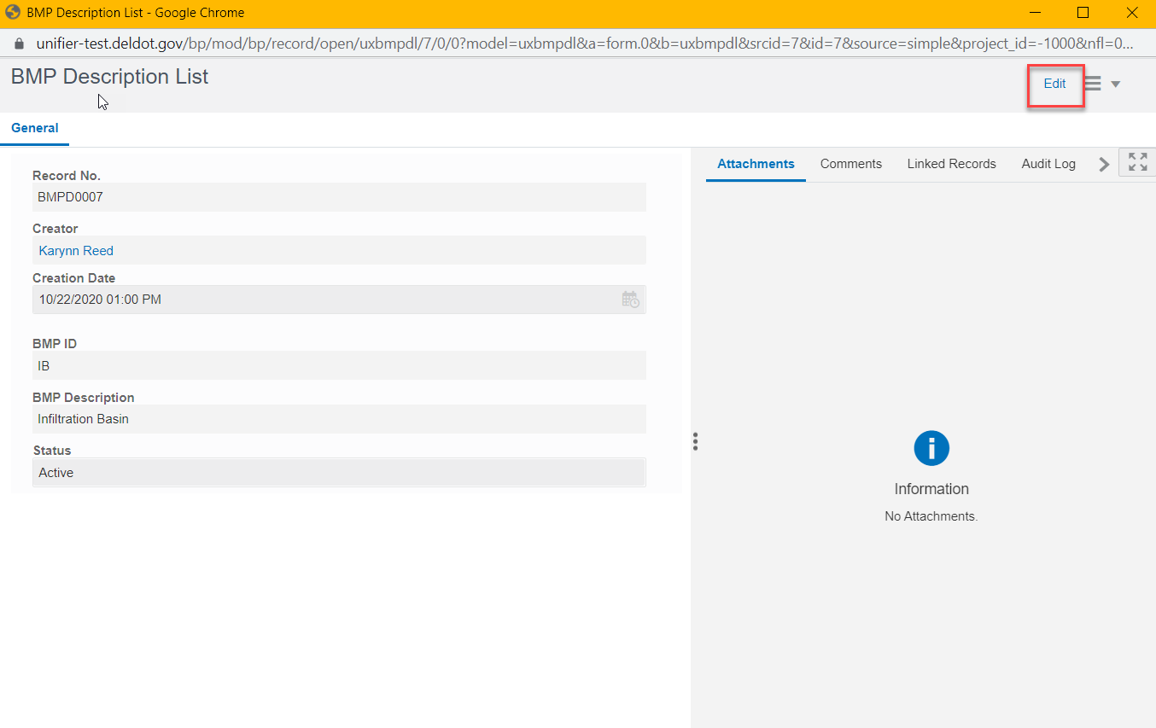
The second method is selecting the BMP from the list by highlighting the BMP/SWM Watershed.
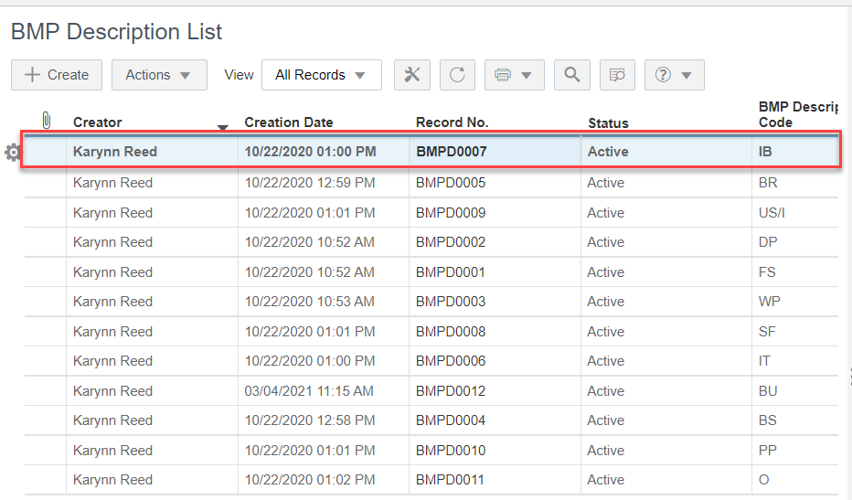
Then click on the Actions Drop down and select Bulk Edit.
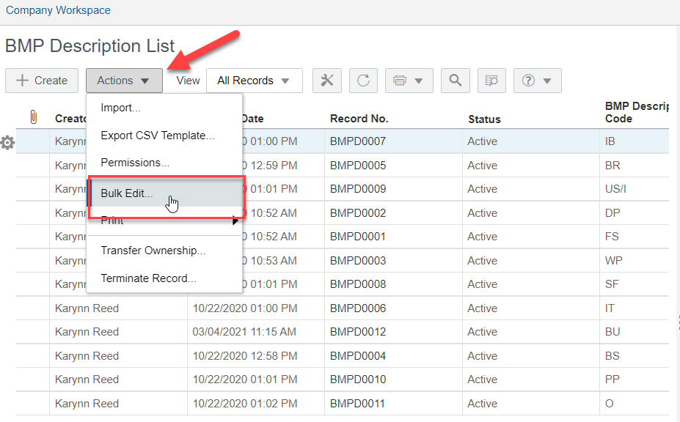
The Bulk edit screen will pop up. Fill out the needed changes, then select Update to update the changes. Once completed click on the Close button on the bottom right hand corner to close the window.
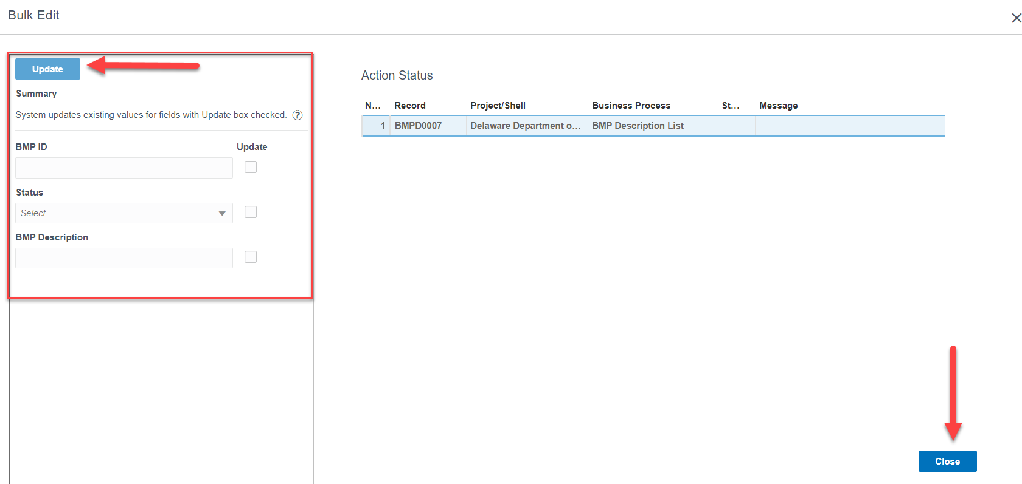
Another feature is the Save option. To Save the information without creating the ID, click on the Save button in the top right corner. This will save the form to the Drafts, in which can be edited later on.
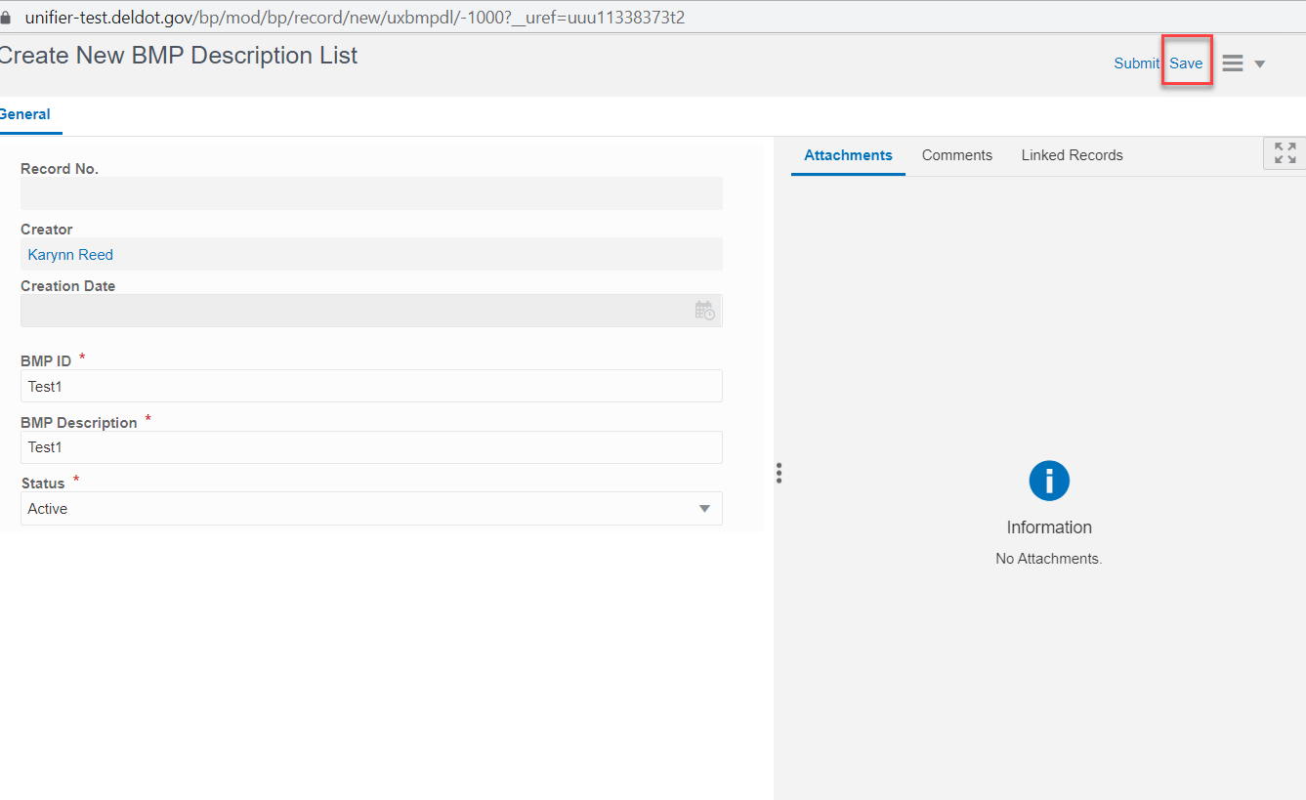
To access the Drafts, click on the home icon in the left hand corner. Once selected, click on Drafts and a list of all forms saved will appear here. Click on the saved form and finish editing. Once completed, click on Send.
