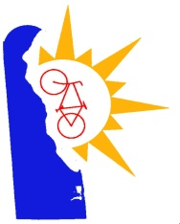

## **Delaware Bicycle Council**

## **April 6, 2022**

## **Zoom Webinar**

## **Meeting Notes**

**Members Present**

Walt Bryan, Sussex County Representative

Fran Cardaci, At-Large Representative

Shebra Hall, Division of Public Health Representative

Tom Hartley, Kent County Representative

Scott Hoffman, At-Large Representative

Mike Krumrine, DNREC Representative

Jackie McDermott, Office of Highway Safety

Evette Morrow, At-Large Representative

Wendy Polasko, DelDOT Representative

Mike Wagner, Department of Education

James Wilson, New Castle County Representative

**Members Absent**

Mack Cochran, Trails & Greenways Council

Martin Lessner, Council on Transportation

Mike Tyler, At-Large Representative

Cpl. Tyler Wright, DE State Police Representative

**DelDOT Support Staff**

Pamela Steinebach, Director of Planning

John Fiori, Bicycle Coordinator, DelDOT

Christina Thomas, Administrative Assistant, DelDOT

**Guests**

Chris Asay, Public

John Bare, Bike Delaware

Jonathan Fleming, Public

Robin Kielkoeski, Public

Vince Watchorn

Bill Weller, Sussex Cyclists

Karen Zarkarion, Public

1. **Welcome/Introductions**

The meeting was called to order at 5:00 p.m. by Scott Hoffman. The Council meeting was held virtually, in which John Fiori took a roll call of Council members present. The quorum was met for the meeting. Scott Hoffman indicated a change to the agenda under New Business where the item Programming to Improve Bicycle Safety was being removed.

**Minutes/Agenda Review:**

The Council reviewed the meeting minutes from the February 2, 2022. where there were no comments. Scott Hoffman asked for a motion to accept the minutes from February 2, 2022. Walt Bryan made the motion to accept the meeting minutes. Tom Hartley seconded the motion. All agreed, no one opposed. Motion passed.

1. **Public Comment**

Bill Weller requested to address the Council, where he wanted to ask about the following four items:

1. What is the status of the project to change the SR-1/Kings Hwy intersection in Lewes where the bicyclist, Jay Kirby, was fatally injured on September 11, 2019?
2. What is the status of the Delaware Route 1 Parallel Shared Use Path study?
3. What is the status of addressing the updated issues identified with Bike Route 1 in Sussex County that was provided to the DBC in July 2020?
4. It is requested DelDOT resume providing the consolidated bicycle-related project updates as had been provided previously. I can’t find any on the DBC Meetings website.

John Fiori responded that question 1 will be addressed during the Priority Bikeway Project Updates; question 2 will be an agenda item at the June Council meeting; question 3 will be addressed during the Bicycle Route 1 Updates; and question 4, the project updates are on the Delaware Bicycle Council website and that the link to the bike project updates will now be placed in the meeting minutes.

John Fiori requested to address the Council, where he wanted to inform the Council that as part of the DelDOT Bicycle Program, bicycles are loaned to the J1 student who work at the resort areas during the summer season. Previously the bike reservations were submitted through ISOP (International Student Outreach Program) and DelDOT would conduct the bike safety seminars and assign a bike to the student from our fleet of bicycles. The fleet consists between 200-250 bicycles. Due to the pandemic ISOP cancelled their program in 2020, 2021 and has cancelled their program for 2022 due to an anticipated low number of students and the lack of volunteers. In 2021 it was decided between ISOP and DelDOT that DelDOT will take over the bicycle reservation portion along with the scheduling the safety seminars and continuing to loan out bikes to the students. In March 2022, the website was completed and the link for J1 students to reserve a bicycle is: <https://deldot.gov/Programs/bike/isop/>. On that website, there is a link for the bicycle reservation form that the students submit to DelDOT.

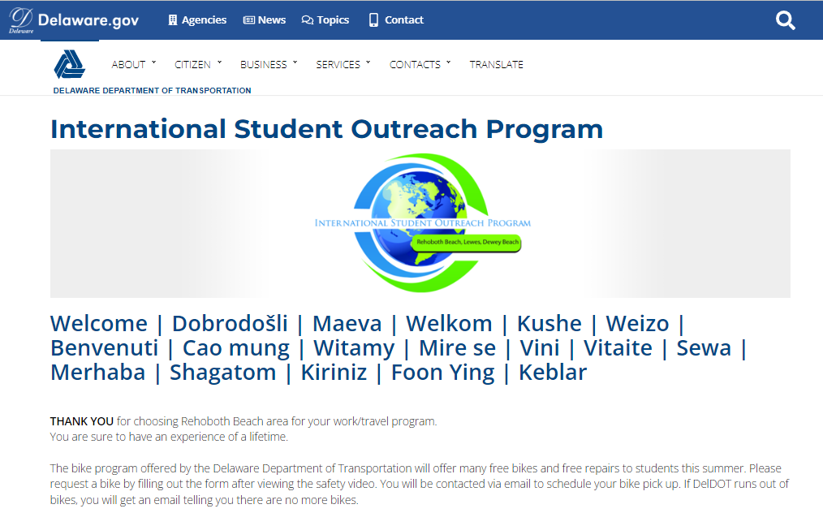

1. **New Business**

**2022 Cycling Infrastructure Innovation Grant Application:**

John Fiori shared the grant application with the Council to review and to see if any changes are need for 2022. John did indicate that he was working with DelDOT DTI to have the application on the Delaware Bicycle Council website by the end of May for applicants to submit on-line instead of filling out a paper copy, but the website will also have a printable PDF available. John indicated the only revisions were the dates, but the content remains the same from last year. Fran Cardaci asked is this was limited to the municipalities of open to other private agencies. John explained that the grant is only open for any Delaware municipalities or any three of the county offices and not open to private entities but if a private entity had an interest in the grant they would be directed to talk to their municipality or county office to see if their project is viable. Scott Hoffman asked for a motion to accept the grant application. Michael Wagner made the motion to accept the documents created. Walt Bryan seconded the motion. All agreed, no one opposed. Motion passed.

**2022** **Cycling Infrastructure Innovation Grant Working Group:**

Scott Hoffman asked for volunteers to be on the 2022 Cycling Infrastructure Innovation Grant Working Group. John stated that this working group has between five to seven volunteers. Scott explained that the working group would review the applications and attend site visits and he found those to be very interesting. Those nominated are Scott Hoffman, Walt Bryan, Michael Wagner, James Wilson, and Michael Krumrine. The nominations were put before the Council for vote. All members voted yes, and no members opposed.

**Bicycle Yield Sign Letter:**

Scott Hoffman presented to draft letter to DelDOT concerning the use of bicycle stop sign when applied on multi-modal pathways. A presentation was made at the February meeting by John Bare and the issue with the stop sign in relation to the Delaware Yield Law and from that meeting Scott and John Bare prepared a letter for DelDOT to consider. John Bare explained genesis of this idea was in October 2017 when Governor John Carney signed the Bicycle-Friendly Delaware Act, making Delaware the second state to make it legal when the coast is clear to treat stop signs as yield signs. Some of the opposition that has come up in the last meeting was that the DE MUTCD does not allow for this, that or the other. Scott and John Bare tried to come up with sign recommendations that would generate respect by the users and having an array of stop signs is not a way to do that. John Bare then went through the pictures with signs examples. Scott then wanted to discuss the memo and the four things to have DelDOT look at:

1. Use a regular stop sign on trails and multi-modal pathways at intersections with public roads with more than two lanes; at major collector or higher functional classification or at an intersection with any travel way where bicyclists have an inadequate view of conflicting vehicle traffic and where you have slight distance, and it becomes a safety issue.
2. At intersections where the Delaware yield law is applicable that it basically just be a yield sign.
3. Try to cut down on the number of signs along multi-modal pathways where bicycles and pedestrians have the right-of-way.
4. In terms of the bicycle stop and yield signs, the MUTCD does state that where potential visual confusions for motorists exists.

Michael Wagner stated that he does not support the letter at this time. In his opinion, it does not pass the 12-years old test, where children under 16-years old know how to yield and believes the placement of some of the stop signs in the presentation was appropriate. younger children do not really know what the yield sign is. He is okay with cyclists knowing they do not have to stop if they properly scan the area, but removing the stop sign and replacing with a yield sign, he is not sure youth’s riding and crossing roads know what a yield sign is but does believe they know the meaning of a stop sign. Tom Hartley supports the use of yield signs but does like using the stop signs to warn bicyclists of a different situation where they need to stop. Fran Cardaci initial take that if someone who rides a lot and knows what the law is and knows the yield law exists then can justifiably ignore a stop sign and use as a yield sign but for someone who is not local or an occasional rider that not having the big red sign there is not a good thing and sometimes someone may need a reminder. Scott Hoffman indicates there are a couple of issues with this, one being the stop is yield and the other is signs on the path that do not make sense such as riding on the path parallel with the roadway and come up to a driveway for a business and there is a bicycle stop sign; does that mean if I am on a bicycle, I am to stop and a person driving about to turn in, are they expecting me to stop although you were taught that you are to yield to people that are walking down the sidewalk. Fran clarified that if on a bicycle you are not walking and not a pedestrian and is not the same thing. Scott wanted clarification that they don’t have to yield to bicycles. Fran responded that if there is a stop sign for bicycles, vehicles do not have to yield. Scott asked if he was on a bicycle and a person is walking next to me, they can continue without stopping but I would have to stop. Fran clarified that the pedestrian would have to be in the crosswalk to have the right-of-way. Fran also stated she finds those bicycles stop signs at driveways to be very annoying, but she treats them a yield signs but feels if there is a 12-years old, maybe not the best idea to treat it as a yield sign. James Wilson made the motion to support the draft letter. Tom Hartley seconded. John Fiori asked for each Council members vote on the motion, in which there were three (3) votes for yes to support the letter and seven (7) votes for no to support the letter and one (1) abstain. Motion did not pass.

**Gordon’s Pond Elevated Boardwalk Widening Study:**

Michael Krumrine stated that State Parks is in the process of signing on with RK&K to do a feasibility study on widening the elevated boardwalk. There is about an 8-foot clear width span for the existing boardwalk and RK&K will look at alternatives to hopefully get that up to at least a 12-foot width clear span. The thinking is if we go much wider than 12-feet, the pilings that are there now probably are not going to be sufficient to support the larger structure, where we would be back to driving more pilings and that gets into other issues. The plan is to try to come up with a way to do it and utilize as much of the existing structure as possible and still try and get it up to about a 12-foot clear width span. This is in the works right now and it has not officially started and that is only because they are in the process of pushing the paperwork through. Scott Hoffman asked when he thinks it will be done? Michael Krumrine was not sure what the time frame is but will get with Scott the following week. Michael Krumrine also indicated that there is no funding to take any plans to the next level but will have to see what they suggest then determine if it is feasible to move forward.

**Newark to Glasgow Bike Trail:**

Vince Watchorn represents The Friends of Cooch’s Bridge historic site, which is an area just outside of Newark. The site consists of about 200-acres and 10-acres of the property was purchased by the State of Delaware in 2018. The Friends Group was formed in 2020 to advocate for the state-owned portion of the historic site and the lands surrounding it. When we look at that area south of Newark and one of the things that jumped into our minds was that there is a real opportunity for a link for biking, pedestrian access, and even for bicycle commuting that could get us across I-95 and help us connect Newark not just to the other side of 95 but all the way to Cooch’s Bridge. Vince then shared his screen of two different drawings. Vince pointed out properties such as Glasgow Park (in green) to the north and Iron Hill Park (in green) to the south and the connection between these properties is what The Friends started thinking about. The properties that could be impacted by the connection would be the Cooch’s Family Land and the state-owned parcel. Also, would have to do something to acquire or gain access through the Cooch’s Family Land. Then once New Castle County started looking at their idea to go from Glasgow to Iron Hill, why not find some ways to get across I-95. The next slide showed property ownerships, where Vince explained the different property owners. It is not going to be easy but with relative simplicity we could link between government owned properties and even over I-95. The state and County each contributed $100k for a total of $200k for a feasibility study where there will be lots of opportunity for public input. John Fiori asked Vince if he was aware if there’s a DelDOT project for the I-95/SR896 interchange. Vince responded that The Friends group is identified as a consulting party so they are aware of it and are also aware that there is a potential of a bike path of some sort going across as part of that new flyover arrangement and would want to make sure that it links up with this in a way that is not obstructive. John also indicated there is a potential project at Old Baltimore Pike and Old Cooch’s Bridge Road intersection. Vince responded that The Friends also been named a consulting party in that one.

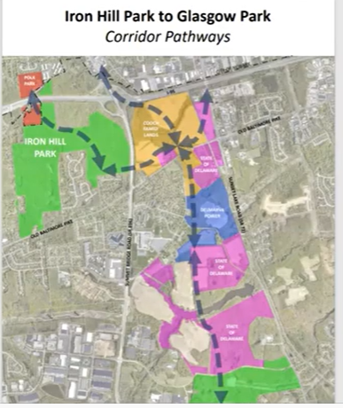 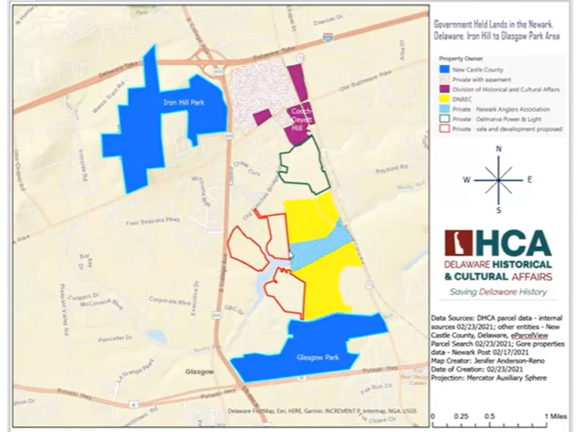

**2022 Walkable Bikeable Delaware Summit – Everyone Goes Home:**

James Wilson presented to the Council the upcoming 2022 Walkable Bikeable Delaware Summit on May 3rd. This year’s summit is going in a different direction, where it is called “Everyone Gets Home”. The summit will be looking at safe approach systems versus traditional road safety practices. There is no cost but if you want to attend you need to register at bikede.org/summit.

**Dover Bike Loop:**

Due to time remaining for the Council meeting and other items to discuss, Scott Hoffman said this item will be moved to the June agenda.

1. **Old Business**

**Safety Initiatives:**

Michael Wagner made a presentation on his personal thoughts on recommendations for consideration with DelDOT’s bike trailer. During the breakout session in February, the idea was what would happen if we got a bike trailer and a DelDOT representative in the session said that DelDOT has a bike trailer, and we use it various groups in the summertime and we used to be at three schools but now just at one school. Michael showed the Council a picture of the bike trailer.

The trailer is filled with bikes, stop signs and safety equipment. DelDOT has a practical bike trailer to present to groups of young people throughout Delaware. According to DelDOT, that prior to the pandemic the bike trailer made presentations during the summer to various groups of young people. These presentations were also presented to several schools during the school year. DelDOT has a very solid bicycle lesson they can present at the schools. Michael Wagner thought that this was great and maybe some people on the Council were aware that this existed. Next is how to get this information out, where health and PE teachers have a professional development day every October, where could DelDOT request to be on their agenda to present what DelDOT can do for schools with regards to Bicycle Education? Michael Wagner made a correlation to what is done in driver education and there is the potential for success and influence. The new DATE Driving Simulator was presented to the driving instructors statewide during the October Driver Education Professional Development Days. The Education Associate for Driver Education also sent out DATE’s information to all the driver education teachers statewide. The results were the DATE driving simulator has 11 scheduled visits to various high schools across the state for the 2021-2022 school year. Considering that driver’s education consists of 10th graders, that there are only about 65 or more high schools in Delaware and that is about a 15% success rate of obtaining access to schools. What we do not know in year two, will those school want that simulator to come back. If DATE comes back again and presents, maybe they pick up more schools. If the presentation is good, more schools will bring the DATE simulator into their school. The bike trailer DelDOT has, if there is a nice presentation, a nice display and present to the PE and Health teachers, that maybe you could have a similar type of increase and you could build from, so instead of having one to five maybe you could have a lot more because there are certainly a lot more elementary schools out there then there are high schools. The next question is should the bike education presented to kids focus on a specific age group? Michael Wagner then showed a bike safety video from the Netherlands that focus on ten and eleven-year-olds. Michael Wagner stated that 200-thousand kids participate in this yearly and in the video, they were out in real traffic, they had safety vests on, they all had the same type of bike. This is an example of what could be and maybe this is something the Council could start a conversation. If this idea was liked, how can the Council further support the efforts? Also, must take into consideration that America is a very diverse place, and you may have a 10-year or 11year old that does not know how to ride a bike and there are special kind of bikes that are built that can assist with helping that person. John Fiori stated he is all for trying to get more schools involved but he is one person and his schedule gets full so if more and more schools want to have a bike rodeo, then what needs to be considered is that we teach the teacher, so if schools are interested in doing this for multiple years, then DelDOT could teach the teacher and provide all the information to teach a bicycle safety class and how to do a bicycle rodeo, where they would contact DelDOT and John would drop off the bike trailer at the school and pick it up the day after the school is done. If the program should really take off, there may be a need to purchase multiple trailers and equipment. Michael Wagner indicated that a train the trainer is a very good option because of limited training personnel. Shebra Hall indicated they are currently looking for presenters on Professional Development Day and for train the trainer that could be part of the presentation. This is a great opportunity to partner with the Department of Education and with SHAPE delaware, which is a professional society that supports health and PE teachers across the state. Michael Wagner asked if someone from DelDOT be available to be a presenter that day? John Fiori responded that sine he is the DelDOT bicycle Coordinator he could do that. Scott Hoffman also indicated maybe having a volunteer from the Bicycle Council be a presenter as well.

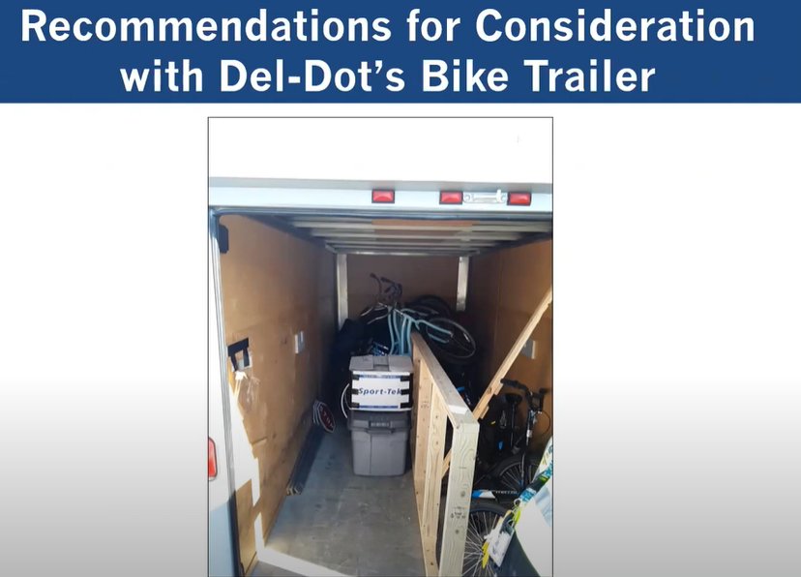 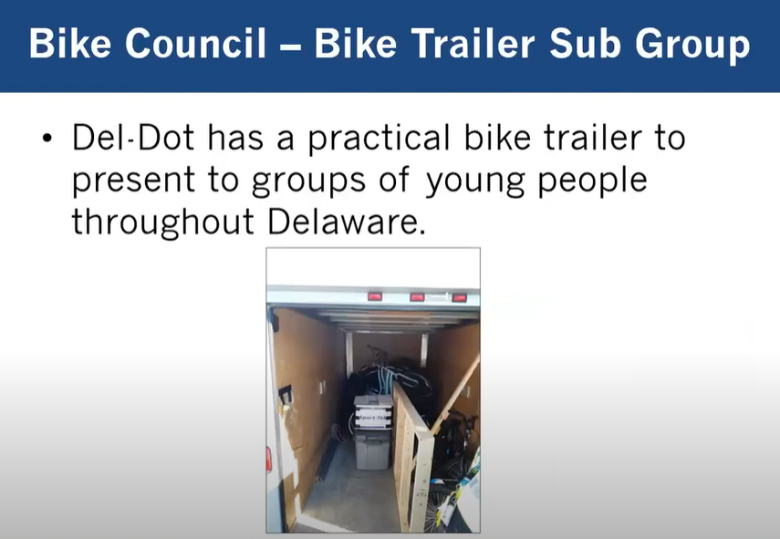

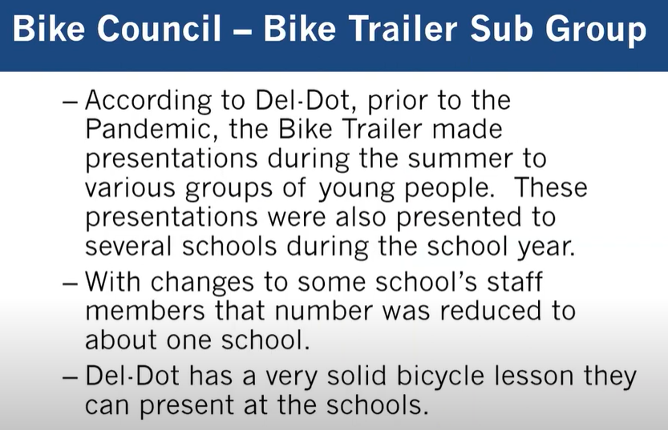 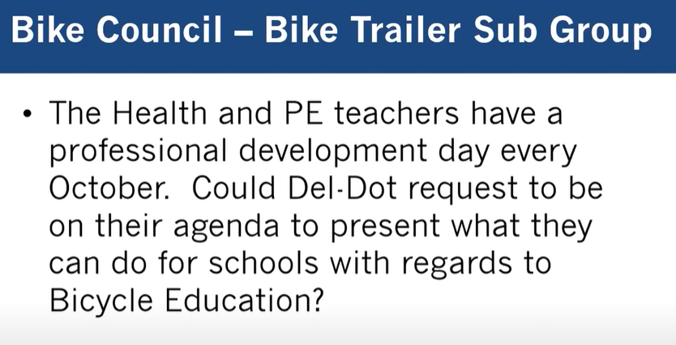

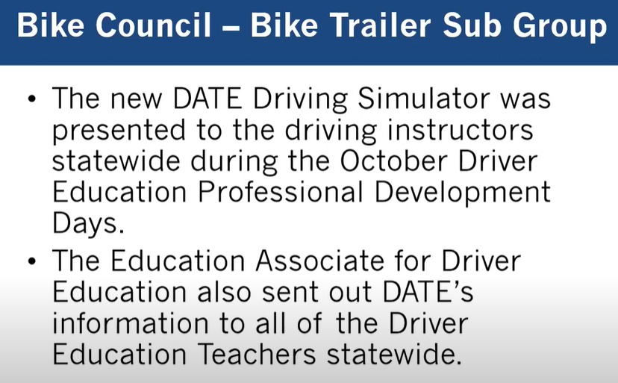 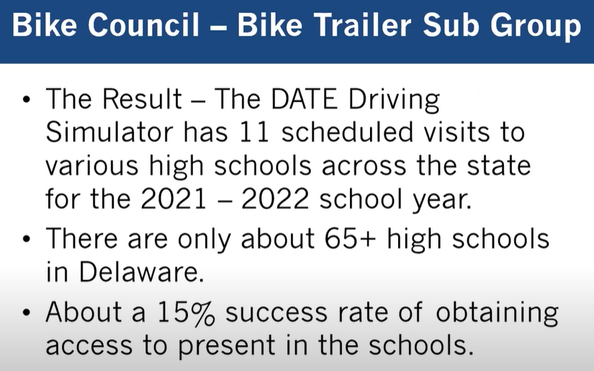

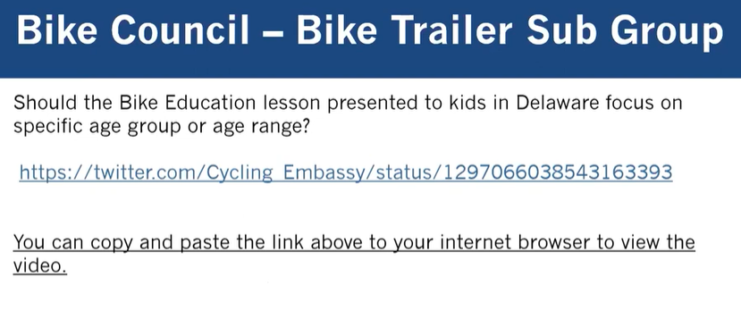 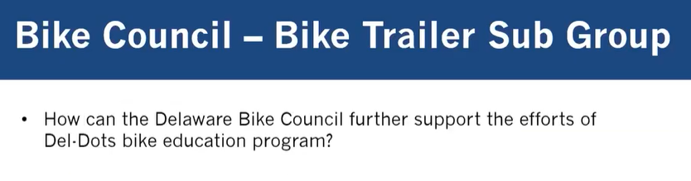

**Bicycle Route 1 Update:**

Due to time remaining for the Council meeting, Scott Hoffman asked Michael Krumrine if he could defer to the June meeting and Michael ho no objections.

**Priority Bikeway Projects Update:**

John Fiori provided updates to various DelDOT Bicycle projects throughout the state. If one exists, the DelDOT Portal Website for that project has been added. For a complete list of all project updates, go to: [Delaware Bike Council - Delaware Department of Transportation (deldot.gov)](https://deldot.gov/Programs/bike/biking_in_delaware/index.shtml?dc=bikenews)

Scott Hoffman entertained a motion to adjourn. Walt Bryan made the motion to adjourn the meeting. Fran Cardaci seconded the motion at 7:07 p.m. All agreed, no one opposed. Motion passed.

**Next meeting: Wednesday June 1, 2022, from 5:00 p.m. to 7:00 p.m. to be held virtually unless otherwise determined.**

To view this Delaware Bicycle Council meeting video on YouTube:

[DBC Meeting 4-6-2022 - YouTube](https://www.youtube.com/watch?v=L6xyCXpqaEM)