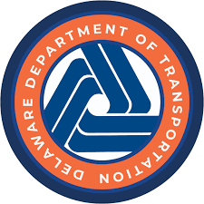
Delaware Department of Transportation
[Secretary Name (Shanté Hastings, P.E.)]
Secretary
Virtual Public Workshop
[TXXXXXXXXX] – [Project Title]
[Project website URL with link]

[Place relevant image(s) of the project here. Example images
that can be used are an aerial map with the project location highlighted, a relevant cross section of the proposed improvement, and a depiction of the proposed improvements transposed on top of aerial imagery. Consider adding relevant information like a north arrow, legend, roadway labels, landmark information or other similar information. The image can be
resized as needed for clarity and for overall presentation
quality.]

Beginning [Month] [Day], [Year]

The Delaware Department of Transportation (DelDOT) will be presenting a virtual public workshop to solicit public input [Briefly describe what DelDOT is soliciting public input on (for the proposed side path improvements along Old Baltimore Pike from SR 72 to Walther Road)]. [Briefly describe the goals of the project or study being presented (The purpose of the proposed side path improvements is to improve mobility for all users within the project limits. This workshop will also provide an update on the project’s schedule)].

Interested persons are invited to visit the project website listed above beginning at [Start time] on [Month] [Day], [Year] to review the proposed improvements and provide comments. Comments will be accepted until [Month] [Day], [Year]. The public is encouraged to express their views in writing for the proposed improvements. Comments can be mailed to DelDOT Community Relations, P.O. Box 778, Dover, DE 19903, submitted through the project website, or sent via email to dotpublic@delaware.gov.

This virtual public workshop is accessible to persons with disabilities. Persons who require auxiliary aids and services such as qualified interpreters are requested to contact DelDOT by phone at 1-800-652-5600, by mail at DelDOT Community Relations, P.O. Box 778, Dover, DE 19903, or by email at dotpr@delaware.gov at least one week in advance of the workshop.

PUBLIC NOTICE

