Delaware Bridge Design Competition
Getting started with Bentley’s STUDENTserver:

Faculty and students can download Bentley software at no cost to their personal computer through Bentley’s STUDENTserver.

First, visit STUDENTserver at http://apps.bentley.com/StudentServer and click Register

School Code: kuWKWMCg0uiBBRngRXQpmpuhZruuUWYbr/+PTjcSx1VazUBXFnjkmg==

Create your profile:
- Add your School Code to the appropriate field as requested.
- Add your personal information in the remaining form fields.
- Click Submit. An email will be sent to you from Bentley for further verification.
(If you do not receive an email within a few minutes check your spam/junk folder)

Verify your account:
- Click the link in the account verification Email to activate your STUDENTserver account.
- Once you verify your new account, you can log in and access all that STUDENTserver has to offer.

Download software:
- After your username is set up, click SIGN to log-in to the site
- Once you are logged in, click on the “Download Software” page to see all of the products available for download. You can filter for software on the left-hand side. You will need to type “MicroStation PowerDraft” into the search bar. This will be the program you will download.
- You will need to refine the search by selecting “English” as the program language.
- Clicking on the “All Downloads” dropdown will reveal (7) download options
  - If the computer is 32-Bit, please download the 32-Bit version
  - If the computer is 64-Bit, please download “MicroStation PowerDraft CONNECT Edition x64 (SES) Update 13 (English)”
- Keep in mind that you’ll need to look at the site activation key near the top of the download page when you activate the product. (Note: This is not the same as the school code)

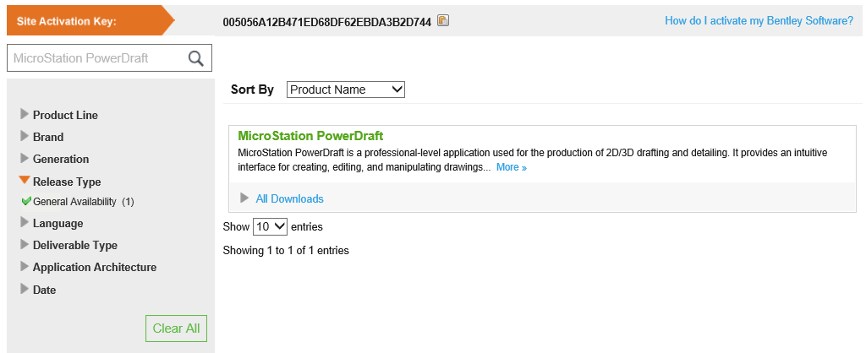
- If you have trouble downloading the software, please contact Nicholas Dean or Scott Walls for assistance.

Software Assistance:

- There are several ways for you to access training on Bentley’s software. Free online trainings are available by clicking on Take Online Training through the STUDENTserver webpage.

- Free academic webinars are offered every other week, and previous webinars are available on-demand after initial launch. You can look at Bentley’s complete list of on-demand webinars here.

- You can also find training paths found in the “Take Online Training” section of Bentley’s STUDENTserver, which will help you find training for any of the products you download. Additionally, there are trainings and help topics in Bentley’s academic community site, which can be found here.

- After you complete a Bentley training, you can print out transcripts through the “certificate and transcript” section of STUDENTserver, which might be useful for you to demonstrate the training that you’ve completed for applying to jobs and internships in the future.

